Исходные графики

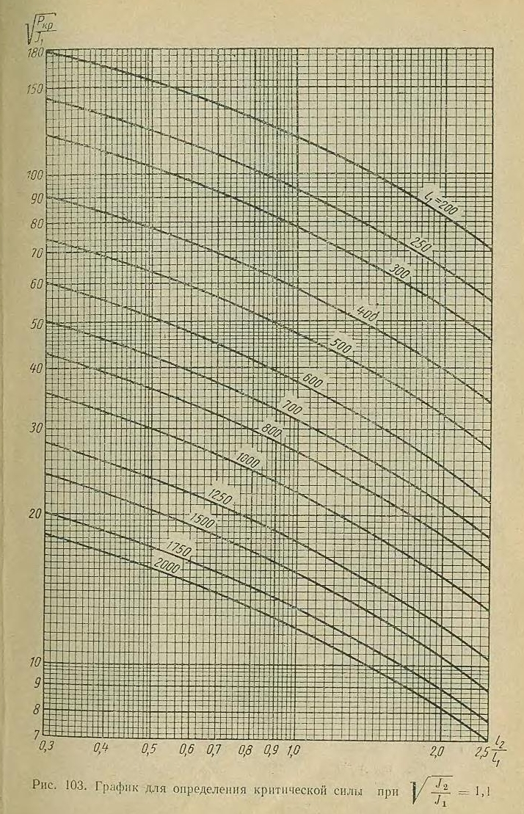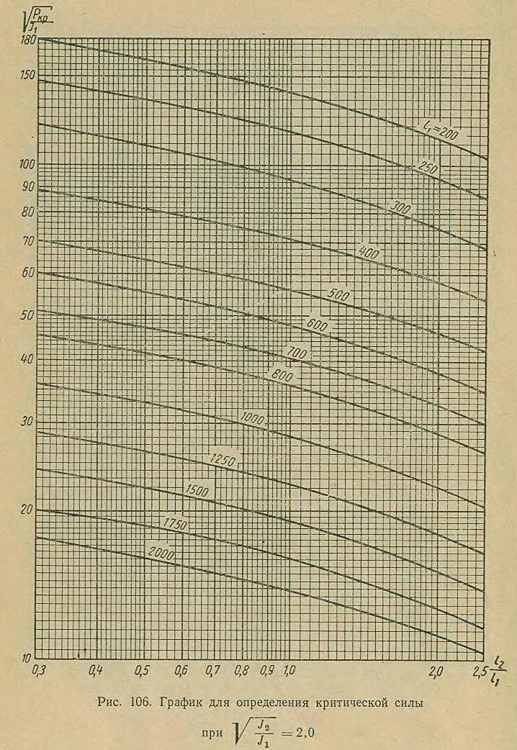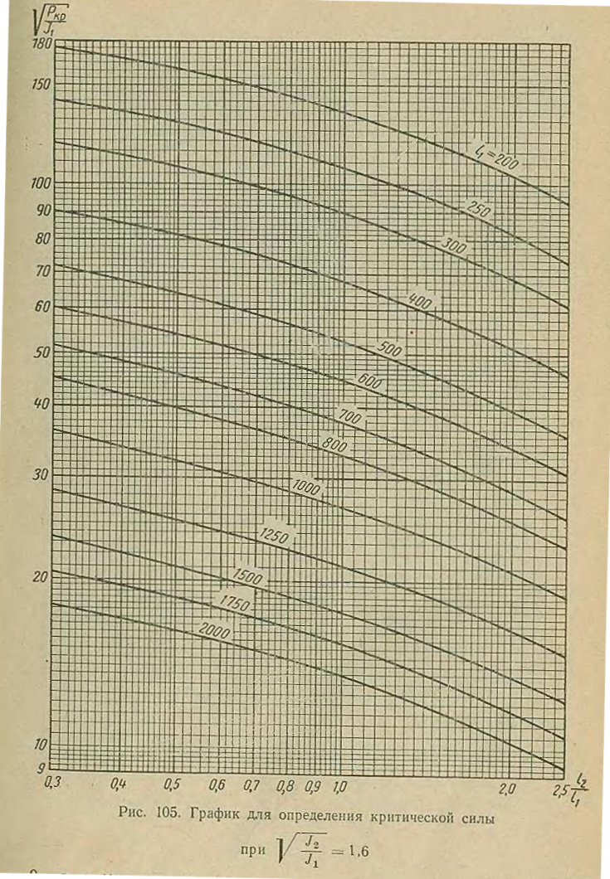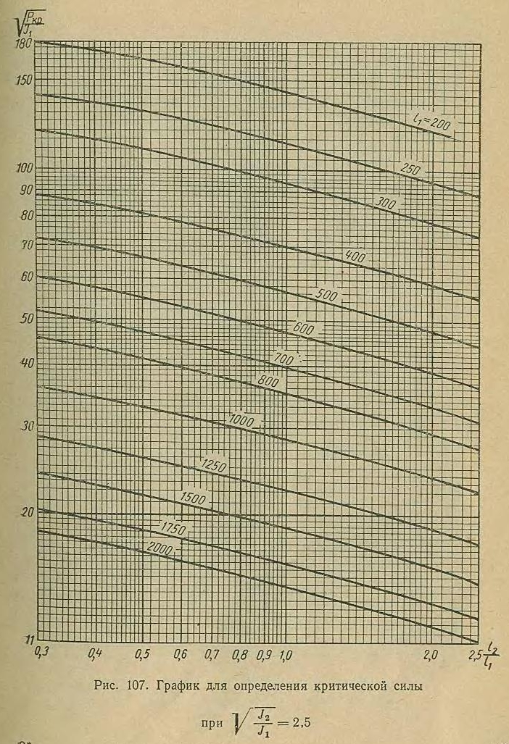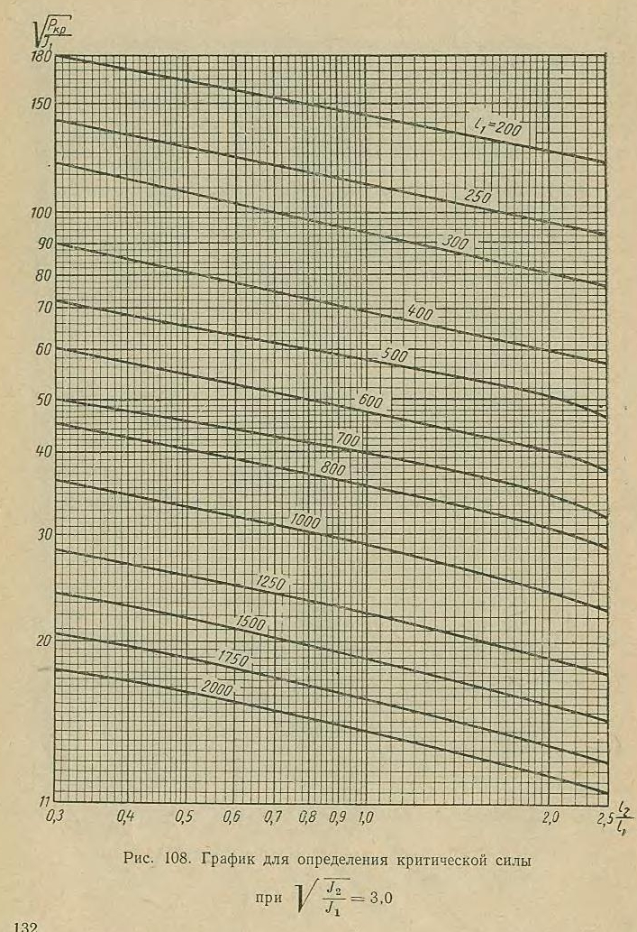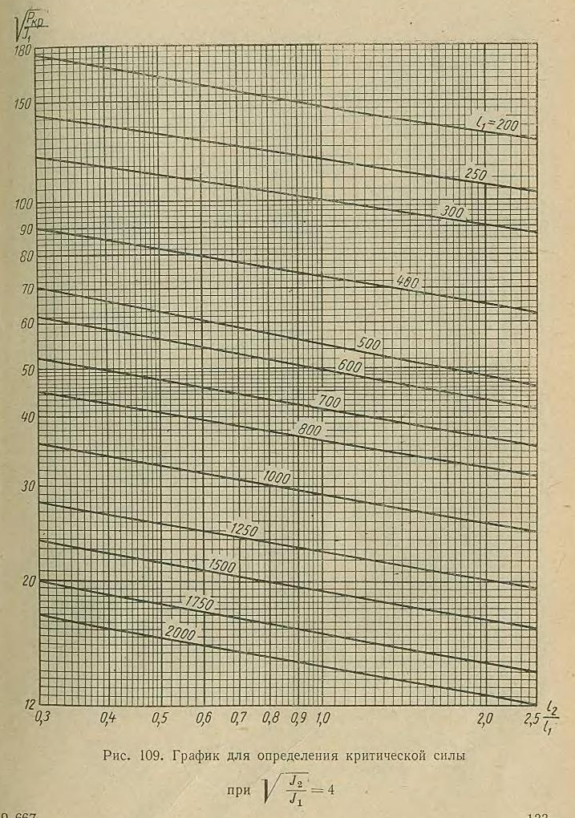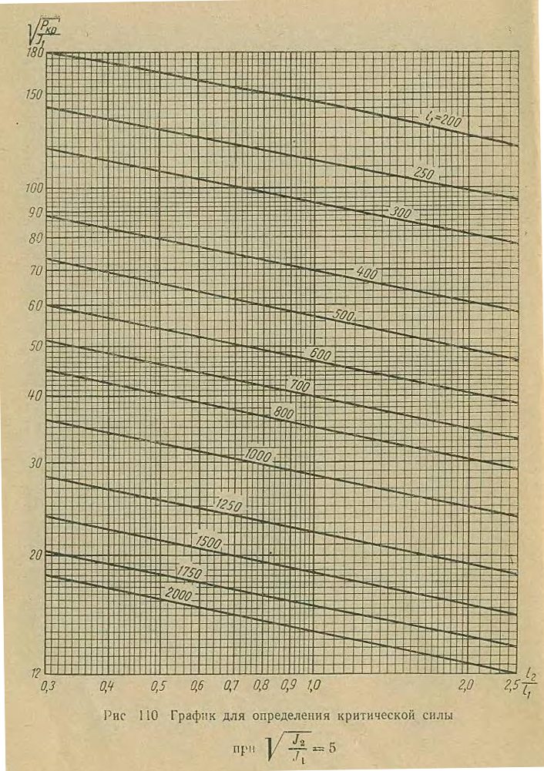

Полученные данные для l1 = 600 и Ω = 1.1 в формате CSV

0,3098765432098765; 60,536828713556446\r\n0,3111111111111111; 60,536828713556446\r\n0,3135802469135802; 60,536828713556446\r\n0,3148148148148148; 60,536828713556446\r\n0,3172839506172839; 60,065202345397836\r\n0,31851851851851853; 60,065202345397836\r\n0,3197530864197531; 60,065202345397836\r\n0,32098765432098764; 60,065202345397836\r\n0,32222222222222224; 60,065202345397836\r\n0,3234567901234568; 59,865441661939535\r\n0,32469135802469135; 59,865441661939535\r\n0,32592592592592595; 59,865441661939535\r\n0,32839506172839505; 59,49347666384586\r\n0,3296296296296296; 59,49347666384586\r\n0,3308641975308642; 59,307494164799024\r\n0,33209876543209876; 59,307494164799024\r\n0,3333333333333333; 59,307494164799024\r\n0,3345679012345679; 59,12151166575218\r\n0,3358024691358025; 58,935529166705344\r\n0,337037037037037; 58,935529166705344\r\n0,33827160493827163; 58,74954666765851\r\n0,3395061728395062; 58,74954666765851\r\n0,34074074074074073; 58,74954666765851\r\n0,3432098765432099; 58,74954666765851\r\n0,34444444444444444; 58,56356416861166\r\n0,345679012345679; 58,377581669564826\r\n0,3469135802469136; 58,377581669564826\r\n0,34814814814814815; 58,19159917051799\r\n0,3506172839506173; 58,19159917051799\r\n0,35185185185185186; 58,19159917051799\r\n0,354320987654321; 58,19159917051799\r\n0,3567901234567901; 57,81963417242431\r\n0,3580246913580247; 57,81963417242431\r\n0,3592592592592593; 57,81963417242431\r\n0,3617283950617284; 57,81963417242431\r\n0,362962962962963; 57,63365167337747\r\n0,3654320987654321; 57,63365167337747\r\n0,3666666666666667; 57,63365167337747\r\n0,36790123456790125; 57,447669174330635\r\n0,3691358024691358; 57,26168667528379\r\n0,3728395061728395; 57,26168667528379\r\n0,3740740740740741; 57,075704176236954\r\n0,3765432098765432; 57,075704176236954\r\n0,37777777777777777; 57,075704176236954\r\n0,3802469135802469; 56,70373917814328\r\n0,3814814814814815; 56,70373917814328\r\n0,3851851851851852; 56,70373917814328\r\n0,3888888888888889; 56,517756679096436\r\n0,39135802469135805; 56,517756679096436\r\n0,3925925925925926; 56,517756679096436\r\n0,39382716049382716; 56,3317741800496\r\n0,39506172839506176; 56,14579168100276\r\n0,3962962962962963; 56,14579168100276\r\n0,39876543209876547; 56,14579168100276\r\n0,4015873015873016; 55,95980918195592\r\n0,4031746031746032; 55,95980918195592\r\n0,40634920634920635; 55,77382668290908\r\n0,407936507936508; 55,587844183862245\r\n0,40952380952380957; 55,40186168481541\r\n0,41269841269841273; 55,40186168481541\r\n0,4142857142857143; 55,40186168481541\r\n0,4158730158730159; 55,215879185768564\r\n0,4174603174603175; 55,02989668672173\r\n0,42063492063492064; 54,84391418767489\r\n0,4222222222222223; 54,84391418767489\r\n0,42380952380952386; 54,84391418767489\r\n0,42539682539682544; 54,657931688628054\r\n0,426984126984127; 54,47194918958121\r\n0,4285714285714286; 54,47194918958121\r\n0,43174603174603177; 54,47194918958121\r\n0,43333333333333335; 54,28596669053437\r\n0,4365079365079365; 54,28596669053437\r\n0,43968253968253973; 53,91400169244069\r\n0,4412698412698413; 53,91400169244069\r\n0,4428571428571429; 53,728019193393855\r\n0,44603174603174606; 53,728019193393855\r\n0,44761904761904764; 53,728019193393855\r\n0,45238095238095244; 53,54203669434702\r\n0,453968253968254; 53,356054195300175\r\n0,4555555555555556; 53,17007169625334\r\n0,4571428571428572; 53,17007169625334\r\n0,46031746031746035; 53,17007169625334\r\n0,46190476190476193; 52,9840891972065\r\n0,4634920634920635; 52,798106698159664\r\n0,4650793650793651; 52,798106698159664\r\n0,4666666666666667; 52,61212419911282\r\n0,4698412698412699; 52,61212419911282\r\n0,4714285714285715; 52,61212419911282\r\n0,47301587301587306; 52,42614170006598\r\n0,47460317460317464; 52,24015920101915\r\n0,4761904761904762; 52,24015920101915\r\n0,47936507936507944; 52,24015920101915\r\n0,480952380952381; 52,24015920101915\r\n0,4841269841269842; 52,05417670197231\r\n0,48571428571428577; 52,05417670197231\r\n0,48888888888888893; 52,05417670197231\r\n0,4904761904761905; 52,05417670197231\r\n0,4920634920634921; 52,05417670197231\r\n0,4936507936507937; 52,05417670197231\r\n0,49523809523809526; 52,05417670197231\r\n0,4984126984126985; 52,05417670197231\r\n0,5; 52,05417670197231\r\n0,5038461538461539; 51,68221170387863\r\n0,5057692307692309; 51,68221170387863\r\n0,5096153846153847; 51,68221170387863\r\n0,5115384615384616; 51,68221170387863\r\n0,5153846153846154; 51,68221170387863\r\n0,5173076923076924; 51,68221170387863\r\n0,5211538461538462; 51,68221170387863\r\n0,5230769230769231; 51,49622920483179\r\n0,526923076923077; 51,49622920483179\r\n0,528846153846154; 51,49622920483179\r\n0,5307692307692309; 51,31024670578495\r\n0,5326923076923078; 51,12426420673811\r\n0,5346153846153847; 51,12426420673811\r\n0,5384615384615385; 51,12426420673811\r\n0,5403846153846155; 51,12426420673811\r\n0,5423076923076924; 50,938281707691274\r\n0,5442307692307693; 50,938281707691274\r\n0,5461538461538462; 50,938281707691274\r\n0,55; 50,566316709597594\r\n0,5519230769230771; 50,566316709597594\r\n0,553846153846154; 50,38033421055076\r\n0,5557692307692309; 50,38033421055076\r\n0,5576923076923078; 50,38033421055076\r\n0,5596153846153847; 50,19435171150392\r\n0,5615384615384617; 50,008369212457076\r\n0,5634615384615386; 50,008369212457076\r\n0,5653846153846155; 49,84794204283096\r\n0,5673076923076924; 49,84794204283096\r\n0,5692307692307693; 49,84794204283096\r\n0,5711538461538462; 49,688719051030944\r\n0,5730769230769232; 49,52949605923093\r\n0,5750000000000002; 49,370273067430915\r\n0,578846153846154; 49,370273067430915\r\n0,5807692307692309; 49,211050075630894\r\n0,5826923076923078; 49,05182708383089\r\n0,5846153846153848; 49,05182708383089\r\n0,5865384615384617; 48,892604092030865\r\n0,5903846153846155; 48,57415810843084\r\n0,5923076923076924; 48,57415810843084\r\n0,5942307692307693; 48,57415810843084\r\n0,5961538461538463; 48,57415810843084\r\n0,5980769230769232; 48,57415810843084\r\n0,6027027027027029; 48,41493511663082\r\n0,6054054054054057; 48,41493511663082\r\n0,610810810810811; 48,096489133030786\r\n0,6135135135135138; 48,096489133030786\r\n0,6189189189189191; 47,93726614123077\r\n0,6270270270270273; 47,93726614123077\r\n0,6324324324324327; 47,77804314943076\r\n0,6351351351351354; 47,61882015763074\r\n0,6405405405405409; 47,45959716583073\r\n0,6432432432432436; 47,45959716583073\r\n0,6459459459459463; 47,45959716583073\r\n0,6540540540540545; 47,45959716583073\r\n0,6567567567567572; 47,30037417403071\r\n0,6594594594594598; 47,14115118223069\r\n0,6621621621621626; 47,14115118223069\r\n0,6648648648648653; 46,98192819043068\r\n0,6675675675675681; 46,98192819043068\r\n0,6702702702702708; 46,98192819043068\r\n0,6756756756756761; 46,98192819043068\r\n0,6783783783783789; 46,822705198630665\r\n0,6810810810810816; 46,66348220683065\r\n0,6837837837837843; 46,66348220683065\r\n0,686486486486487; 46,50425921503063\r\n0,6918918918918924; 46,50425921503063\r\n0,6945945945945952; 46,50425921503063\r\n0,7000000000000004; 46,50425921503063\r\n0,7021739130434788; 46,345036223230615\r\n0,704347826086957; 46,1858132314306\r\n0,7065217391304353; 46,1858132314306\r\n0,7086956521739136; 46,1858132314306\r\n0,7108695652173919; 46,026590239630586\r\n0,7130434782608701; 46,026590239630586\r\n0,7152173913043485; 46,026590239630586\r\n0,719565217391305; 46,026590239630586\r\n0,7217391304347833; 45,86736724783057\r\n0,7239130434782616; 45,70814425603056\r\n0,7260869565217398; 45,70814425603056\r\n0,7282608695652182; 45,70814425603056\r\n0,7326086956521747; 45,70814425603056\r\n0,734782608695653; 45,548921264230536\r\n0,7413043478260879; 45,38969827243052\r\n0,7434782608695661; 45,23047528063051\r\n0,7456521739130444; 45,07125228883049\r\n0,7478260869565228; 45,07125228883049\r\n0,750000000000001; 44,91202929703048\r\n0,7521739130434792; 44,752806305230465\r\n0,7543478260869576; 44,752806305230465\r\n0,7565217391304359; 44,59358331343044\r\n0,7586956521739141; 44,59358331343044\r\n0,7608695652173925; 44,43436032163043\r\n0,7630434782608707; 44,275137329830415\r\n0,765217391304349; 44,275137329830415\r\n0,7673913043478273; 44,1159143380304\r\n0,7717391304347838; 44,1159143380304\r\n0,7739130434782622; 43,956691346230386\r\n0,7760869565217404; 43,797468354430364\r\n0,7782608695652187; 43,797468354430364\r\n0,780434782608697; 43,63824536263035\r\n0,7847826086956535; 43,63824536263035\r\n0,7869565217391318; 43,479022370830336\r\n0,7891304347826101; 43,31979937903032\r\n0,7913043478260884; 43,31979937903032\r\n0,7934782608695666; 43,16057638723031\r\n0,7978260869565232; 43,16057638723031\r\n0,8000000000000022; 43,16057638723031\r\n0,8030303030303053; 43,001353395430286\r\n0,8060606060606085; 42,84213040363027\r\n0,8090909090909117; 42,84213040363027\r\n0,8151515151515182; 42,84213040363027\r\n0,8181818181818213; 42,68290741183026\r\n0,8242424242424278; 42,68290741183026\r\n0,8272727272727309; 42,52368442003024\r\n0,8303030303030342; 42,36446142823023\r\n0,8333333333333374; 42,36446142823023\r\n0,8363636363636406; 42,20523843643021\r\n0,842424242424247; 42,20523843643021\r\n0,8454545454545502; 42,20523843643021\r\n0,8484848484848534; 42,04601544463019\r\n0,8515151515151567; 41,88679245283018\r\n0,8545454545454598; 41,88679245283018\r\n0,8575757575757631; 41,727569461030164\r\n0,8636363636363694; 41,727569461030164\r\n0,8696969696969759; 41,409123477430136\r\n0,8757575757575823; 41,249900485630114\r\n0,8787878787878856; 41,249900485630114\r\n0,8818181818181887; 41,249900485630114\r\n0,8848484848484919; 41,0906774938301\r\n0,8878787878787952; 40,931454502030086\r\n0,8909090909090983; 40,931454502030086\r\n0,8969696969697047; 40,931454502030086\r\n0,9000000000000088; 40,77223151023007\r\n0,9066666666666771; 40,77223151023007\r\n0,9100000000000112; 40,61300851843006\r\n0,9133333333333454; 40,45378552663004\r\n0,9166666666666796; 40,45378552663004\r\n0,9200000000000138; 40,29456253483002\r\n0,9266666666666822; 40,29456253483002\r\n0,9300000000000164; 40,29456253483002\r\n0,9333333333333506; 40,13533954303001\r\n0,9366666666666847; 39,981628903857924\r\n0,9400000000000189; 39,981628903857924\r\n0,9433333333333531; 39,85915492957746\r\n0,9466666666666872; 39,85915492957746\r\n0,9500000000000214; 39,85915492957746\r\n0,9566666666666898; 39,61420698101653\r\n0,960000000000024; 39,61420698101653\r\n0,9700000000000265; 39,49173300673606\r\n0,9766666666666949; 39,49173300673606\r\n0,9800000000000291; 39,3692590324556\r\n0,9833333333333631; 39,246785058175135\r\n0,9866666666666974; 39,246785058175135\r\n0,9900000000000315; 39,12431108389467\r\n0,9933333333333657; 39,0018371096142\r\n0,9966666666666999; 38,87936313533373\r\n1,0000000000000517; 38,87936313533373\r\n1,0050505050505592; 38,75688916105327\r\n1,0101010101010668; 38,75688916105327\r\n1,0151515151515744; 38,634415186772806\r\n1,020202020202082; 38,511941212492346\r\n1,0252525252525895; 38,511941212492346\r\n1,0303030303030971; 38,38946723821188\r\n1,0353535353536047; 38,26699326393141\r\n1,0404040404041122; 38,144519289650944\r\n1,0454545454546198; 38,144519289650944\r\n1,055555555555635; 38,144519289650944\r\n1,0606060606061425; 38,02204531537048\r\n1,0757575757576652; 37,89957134109002\r\n1,0808080808081728; 37,77709736680955\r\n1,0858585858586804; 37,77709736680955\r\n1,090909090909188; 37,65462339252908\r\n1,1010101010102031; 37,409675443968155\r\n1,1111111111112182; 37,28720146968769\r\n1,1161616161617258; 37,28720146968769\r\n1,1212121212122335; 37,28720146968769\r\n1,126262626262741; 37,16472749540722\r\n1,1313131313132485; 37,04225352112676\r\n1,1363636363637561; 36,91977954684629\r\n1,1515151515152788; 36,797305572565826\r\n1,1565656565657865; 36,5523576240049\r\n1,161616161616294; 36,307409675443964\r\n1,1666666666668015; 36,307409675443964\r\n1,1767676767678168; 36,184935701163496\r\n1,1868686868688318; 35,93998775260257\r\n1,1919191919193395; 35,93998775260257\r\n1,1969696969698471; 35,8175137783221\r\n1,2121212121213698; 35,8175137783221\r\n1,2171717171718774; 35,69503980404164\r\n1,2222222222223849; 35,572565829761174\r\n1,2272727272728925; 35,45009185548071\r\n1,2373737373739075; 35,45009185548071\r\n1,2424242424244152; 35,45009185548071\r\n1,2474747474749228; 35,32761788120024\r\n1,2525252525254302; 35,20514390691978\r\n1,2575757575759379; 35,08266993263931\r\n1,267676767676953; 35,08266993263931\r\n1,2727272727274606; 34,960195958358845\r\n1,2777777777779682; 34,83772198407838\r\n1,2878787878789835; 34,71524800979792\r\n1,2979797979799985; 34,71524800979792\r\n1,3030303030305062; 34,59277403551745\r\n1,3080808080810136; 34,47030006123698\r\n1,3131313131315212; 34,47030006123698\r\n1,3181818181820288; 34,47030006123698\r\n1,3232323232325363; 34,347826086956516\r\n1,328282828283044; 34,347826086956516\r\n1,338383838384059; 34,10287813839559\r\n1,3434343434345666; 34,10287813839559\r\n1,3484848484850742; 33,98040416411512\r\n1,3585858585860895; 33,98040416411512\r\n1,363636363636597; 33,85793018983466\r\n1,3686868686871045; 33,735456215554194\r\n1,3737373737376122; 33,61298224127373\r\n1,3838383838386272; 33,49050826699326\r\n1,3888888888891349; 33,3680342927128\r\n1,3939393939396423; 33,3680342927128\r\n1,4040404040406576; 33,24556031843233\r\n1,4090909090911652; 33,24556031843233\r\n1,4141414141416726; 33,123086344151865\r\n1,4191919191921802; 33,0006123698714\r\n1,4242424242426879; 32,87813839559094\r\n1,434343434343703; 32,87813839559094\r\n1,4393939393942106; 32,75566442131047\r\n1,4444444444447182; 32,63319044703\r\n1,4494949494952256; 32,510716472749536\r\n1,4545454545457333; 32,510716472749536\r\n1,4646464646467483; 32,26576852418861\r\n1,4797979797982712; 32,26576852418861\r\n1,4848484848487786; 32,14329454990814\r\n1,494949494949794; 32,14329454990814\r\n1,5000000000003015; 32,02082057562768\r\n1,505050505050809; 31,898346601347214\r\n1,5101010101013166; 31,775872627066747\r\n1,5151515151518242; 31,775872627066747\r\n1,5202020202023316; 31,653398652786283\r\n1,5252525252528393; 31,530924678505816\r\n1,530303030303347; 31,530924678505816\r\n1,5353535353538543; 31,408450704225352\r\n1,540404040404362; 31,408450704225352\r\n1,5454545454548696; 31,285976729944885\r\n1,550505050505377; 31,16350275566442\r\n1,5555555555558849; 31,041028781383954\r\n1,5606060606063923; 31,041028781383954\r\n1,5656565656569; 30,91855480710349\r\n1,5707070707074076; 30,796080832823026\r\n1,5808080808084226; 30,551132884262096\r\n1,5858585858589302; 30,42865890998163\r\n1,5909090909094377; 30,42865890998163\r\n1,5959595959599453; 30,306184935701165\r\n1,601010101010453; 30,306184935701165\r\n1,6060606060609603; 30,306184935701165\r\n1,611111111111468; 30,183710961420697\r\n1,6161616161619756; 30,061236987140234\r\n1,621212121212483; 29,956331877729255\r\n1,6313131313134983; 29,956331877729255\r\n1,6414141414145136; 29,868995633187772\r\n1,646464646465021; 29,78165938864629\r\n1,6515151515155286; 29,694323144104803\r\n1,6616161616165437; 29,694323144104803\r\n1,6666666666670513; 29,606986899563317\r\n1,671717171717559; 29,519650655021834\r\n1,6767676767680664; 29,519650655021834\r\n1,681818181818574; 29,43231441048035\r\n1,6868686868690816; 29,25764192139738\r\n1,691919191919589; 29,170305676855897\r\n1,696969696970097; 29,170305676855897\r\n1,7020202020206043; 29,08296943231441\r\n1,707070707071112; 28,995633187772924\r\n1,7121212121216196; 28,90829694323144\r\n1,7222222222226347; 28,90829694323144\r\n1,7323232323236497; 28,73362445414847\r\n1,7373737373741573; 28,646288209606986\r\n1,742424242424665; 28,646288209606986\r\n1,7474747474751724; 28,558951965065503\r\n1,75252525252568; 28,471615720524017\r\n1,7575757575761877; 28,38427947598253\r\n1,767676767677203; 28,38427947598253\r\n1,777777777778218; 28,209606986899562\r\n1,7828282828287256; 28,209606986899562\r\n1,787878787879233; 28,122270742358076\r\n1,7979797979802483; 28,122270742358076\r\n1,8080808080812634; 27,94759825327511\r\n1,813131313131771; 27,94759825327511\r\n1,8181818181822784; 27,860262008733624\r\n1,823232323232786; 27,772925764192138\r\n1,8282828282832937; 27,685589519650655\r\n1,838383838384309; 27,59825327510917\r\n1,848484848485324; 27,59825327510917\r\n1,8535353535358317; 27,510917030567686\r\n1,8636363636368467; 27,4235807860262\r\n1,8686868686873543; 27,336244541484717\r\n1,8737373737378618; 27,336244541484717\r\n1,8787878787883694; 27,336244541484717\r\n1,883838383838877; 27,24890829694323\r\n1,8888888888893844; 27,161572052401745\r\n1,8939393939398923; 27,161572052401745\r\n1,9040404040409071; 27,161572052401745\r\n1,909090909091415; 27,074235807860262\r\n1,9141414141419224; 26,986899563318776\r\n1,91919191919243; 26,899563318777293\r\n1,9242424242429377; 26,899563318777293\r\n1,929292929293445; 26,812227074235807\r\n1,9343434343439527; 26,812227074235807\r\n1,9393939393944604; 26,724890829694324\r\n1,9444444444449678; 26,637554585152838\r\n1,9494949494954754; 26,637554585152838\r\n1,9595959595964905; 26,55021834061135\r\n1,9646464646469983; 26,55021834061135\r\n1,979797979798521; 26,375545851528383\r\n1,9848484848490284; 26,2882096069869\r\n1,9949494949500437; 26,2882096069869\r\n2,0077639751561365; 26,11353711790393\r\n2,0155279503114256; 26,026200873362445\r\n2,0232919254667143; 26,026200873362445\r\n2,0310559006220035; 25,93886462882096\r\n2,0388198757772926; 25,851528384279476\r\n2,0465838509325813; 25,851528384279476\r\n2,0543478260878705; 25,764192139737993\r\n2,0621118012431596; 25,764192139737993\r\n2,0698757763984488; 25,764192139737993\r\n2,0854037267090266; 25,58951965065502\r\n2,0931677018643158; 25,58951965065502\r\n2,116459627330183; 25,502183406113538\r\n2,124223602485472; 25,327510917030565\r\n2,131987577640761; 25,327510917030565\r\n2,13975155279605; 25,240174672489083\r\n2,147515527951339; 25,1528384279476\r\n2,155279503106628; 25,065502183406114\r\n2,1630434782619172; 25,065502183406114\r\n2,170807453417206; 24,978165938864628\r\n2,178571428572495; 24,978165938864628\r\n2,1863354037277842; 24,890829694323145\r\n2,194099378883073; 24,80349344978166\r\n2,201863354038362; 24,716157205240172\r\n2,2173913043489404; 24,541484716157207\r\n2,225155279504229; 24,45414847161572\r\n2,2406832298148074; 24,27947598253275\r\n2,2484472049700965; 24,27947598253275\r\n2,2562111801253852; 24,27947598253275\r\n2,2639751552806744; 24,192139737991265\r\n2,2717391304359635; 24,192139737991265\r\n2,2872670807465414; 24,10480349344978\r\n2,3027950310571197; 23,930131004366814\r\n2,310559006212409; 23,842794759825328\r\n2,3183229813676975; 23,66812227074236\r\n2,3260869565229867; 23,580786026200872\r\n2,333850931678276; 23,31877729257642\r\n2,3493788819888537; 23,056768558951966\r\n2,357142857144143; 22,96943231441048\r\n2,364906832299432; 22,882096069868997\r\n2,3726708074547207; 22,79475982532751\r\n2,38043478261001; 22,707423580786028\r\n2,388198757765299; 22,62008733624454\r\n2,395962732920588; 22,62008733624454\r\n2,419254658386455; 22,532751091703055\r\n2,4270186335417443; 22,445414847161572\r\n2,434782608697033; 22,358078602620086\r\n2,442546583852322; 22,270742358078603\r\n2,4503105590076113; 22,183406113537117\r\n2,4580745341629004; 22,096069868995635\r\n2,4736024844734783; 21,921397379912662\r\n2,4813664596287675; 21,921397379912662\r\n2,489130434784056; 21,921397379912662\r\n2,4968944099393453; 21,83406113537118\r\n2,5046583850946345; 21,83406113537118\r\n2,5124223602499236; 21,83406113537118\r\n2,5201863354052128; 21,746724890829693\r\n2,5279503105605015; 21,65938864628821\r\n2,5357142857157906; 21,572052401746724\r\n2,5434782608710798; 21,397379912663755\r\n

Исходный код программы для обработки результатов на языке GO

package main

import (

"os"

"encoding/json"

"math"

//"fmt"

"strconv"

"fmt"

)

type jsonT struct {

Data data `json:"data"`

}

type data struct {

W float64 `json:"W"`

Data []graph `json:"data"`

}

type exp struct {

base float64

pow float64

}

type graph struct {

L int `json:"l"`

first exp

second exp

Data [][2]float64 `json:"data"`

}

func main() {

fmt.Println()

//fmt.Printf("%s\n",strconv.FormatFloat(float64(0), 'f', 0, 64))

println(" 200",

" 250",

" 300",

" 400",

" 500",

" 600",

" 700",

" 800",

" 1000",

" 1250",

" 1500",

" 1750",

" 2000")

arr := []string{"1.1","1.6","2","2.5","5"}

arrT := []data{}

for _, W := range arr{

data := jsonT{}

file,_ := os.Open(W + ".json")

defer file.Close()

reader := json.NewDecoder(file)

reader.Decode(&data)

arrT = append(arrT, data.Data)

}

file,_ := os.OpenFile("here.json", os.O_RDWR, 0777)

defer file.Close()

reader := json.NewEncoder(file)

reader.Encode(&arrT)

second := make(map[int][][2]float64)

for _, o := range arrT{

str := "" + strconv.FormatFloat(o.W, 'f', 3, 64) + " "

for _, obj := range o.Data{

a, b := Appr(obj.Data)

obj.first.base = a

obj.first.pow = b

/* fmt.Printf("w=%s, l=%s, %s*x^%s\n",

strconv.FormatFloat(float64(o.W), 'f', 3, 64),

strconv.FormatFloat(float64(obj.L), 'f', 3, 64),

strconv.FormatFloat(a, 'f', 3, 64),

strconv.FormatFloat(b, 'f', 3, 64),

)*/

// TODO меняем знак у степени!!!!!!!!!!!!!!!!!

str += strconv.FormatFloat(-1 * obj.first.pow, 'f', 3, 64) + " "

second[obj.L] = append(second[obj.L], [2]float64{o.W ,-1 * obj.first.pow})

//str += strconv.FormatFloat(obj.base, 'f', 3, 64) + " "

}

println(str)

}

sec := make(map[int]exp)

for i, p := range second{

a, b := Appr(p)

sec[i] = exp{a, b}

}

fmt.Printf("%v\n", sec)

for _, p := range sec{

println(strconv.FormatFloat(p.base, 'f', 3, 64) + " " + strconv.FormatFloat(p.pow, 'f', 3, 64))

}

}

/**

a is coefficient of x

b is power of x

*/

func Appr(arr [][2]float64) (a, b float64){

var S1, S2, S3, S4 float64

for _, r := range arr{

r[0] = math.Pow(float64(10), r[0])

s1 := math.Log10(r[0])

S1 += s1

S2 += s1 * s1

s3 := math.Log10(r[1])

S3 += s3

S4 += s1 * s3

}

n := float64(len(arr))

a = math.Pow(float64(10), (S3*S2 - S4*S1)/(n * S2 - S1 * S1))

b = (n * S4 - S1*S3)/(n * S2 - S1 * S1)

return

}